**Remote Controlled Bluetooth Car**

Guided by : Prof. S. GopiKrishnan

( EC ID : 190171 )

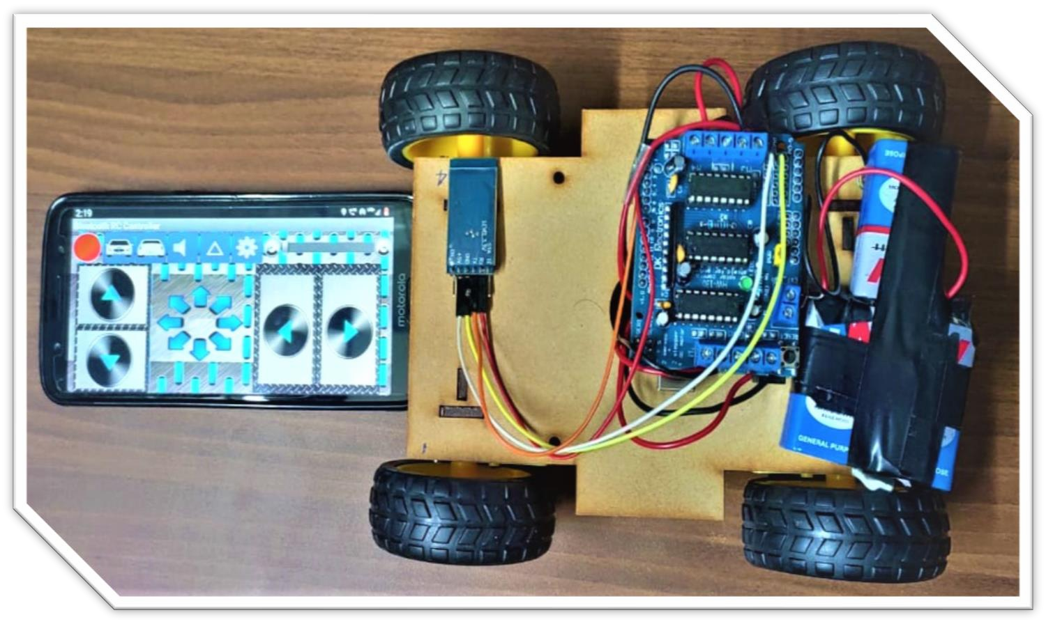

Submitted By :

G. Varaprasad(19BCE7048)

K. Sai Srinivas(19BCE7017)

B. Sai Bipin(19BCD7025)

K.J. Sreeja(19MIS7046)

N. Prudhvi Sai(19BCE7129)

# Table of contents :

* Introduction
* Related existence of the project
* Abstract
* Circuit Diagram
* Explanation of Circuit
* Components description :
  + Bluetooth Module (HC-05)
  + DC motors
  + Arduino UNO
  + Motor Driver IC (L293D)
  + Jumper Wires
  + Bluetooth Remote Control app
* Hardware analysis
* Images of the original circuit
* Video of demo
* Coding
* Advantages of the project
* Future Scope and Conclusion

# Introduction

* We are now living in the 21st century. Now, smart phone has become the most essential thing in our daily life.
* Android application based smart phones are becoming each time more powerful and equipped with several accessories that are useful for Robots.
* This project describes how to control a robot using mobile through Bluetooth communication, some features about Bluetooth technology, components of the mobile and robot.
* Bluetooth has changed how people use digital device at home or office, and has transferred traditional wired digital devices into wireless devices.
* **Bluetooth controlled car** is controlled by using Android mobile phone instead of any other method like buttons, gesture etc.
* Here only needs to touch button in android phone to control the car in forward, backward, left and right directions.
* So here android phone is used as transmitting device and

Bluetooth module placed in car is used as receiver.

* Android phone will transmit command using its in-built Bluetooth to car so that it can move in the required direction like moving forward, reverse, turning left, turning right and stop.

# Related existence of the Project

* There are several ways to capture a human gesture that a machine would be able to understand. The gesture can be captured using a camera, or a data glove, or can also be captured via Bluetooth or infrared waves, Acoustic, Tactile, optical or motion technological means. With the advent of Smartphone and other modern technologies, operating machines have become more flexible.
* Apart from hand gesture recognition, emotional gesture

recognition from face is also done in some cases. There are two types of gestures used in gesture recognition: Online gestures and Offline gestures. In Online gestures, direct manipulations like rotation and scaling are done. In Offline gestures, the processing is done only after the user interacts with the object

* There are various modes of communication between the microcontroller of the robot and the Smartphone. However, the popularly used means of communication is done via RF, Bluetooth or Wi-Fi. Using RF limits the distance from which the robot can be controlled. Using Wi-Fi increases the overall cost for setup. So, the robot has been built with Bluetooth which has intermediate range of distance covered and cost between RF and Wi-Fi.

# Abstract

* We present a review of robots controlled by mobile phone via moving the robot upward, backward, left and right side by the android application such as Arduino, Bluetooth.
* Bluetooth has changed how people use digital device at home or office, and has transferred traditional wired digital devices into wireless devices.
* Here we are using Bluetooth communication, interface microcontroller and android application. We are using Arduino software to interface the Bluetooth module with microcontroller.
* According to commands received from android the robot motion can be controlled.
* 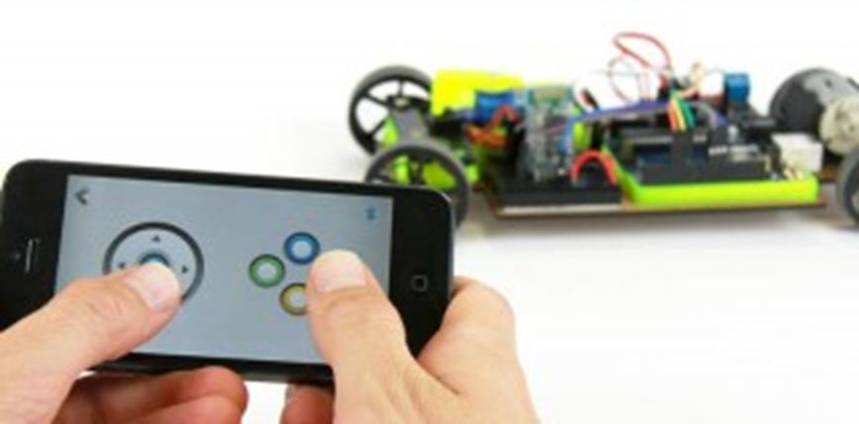We derived simple solutions to provide a framework for building robots with very low cost but with high computation and sensing capabilities provided by the smart phone that is used as a control device.

**Circuit Diagram**

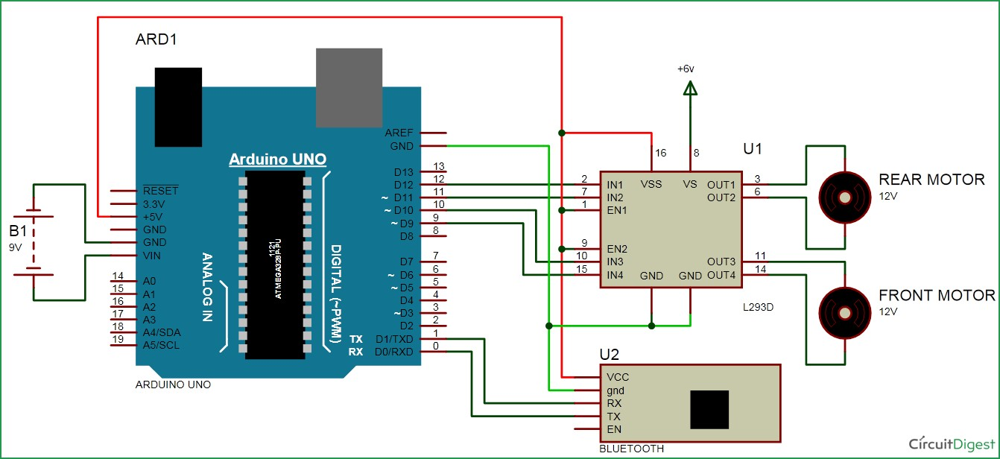

## Complete Circuit connections.

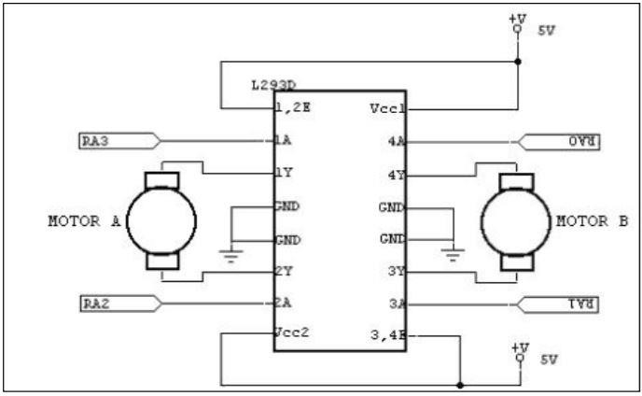

**Motor Driver IC with circuit connections**.

**Explanation of the Circuits :**

**Block diagram of the proposed System :**

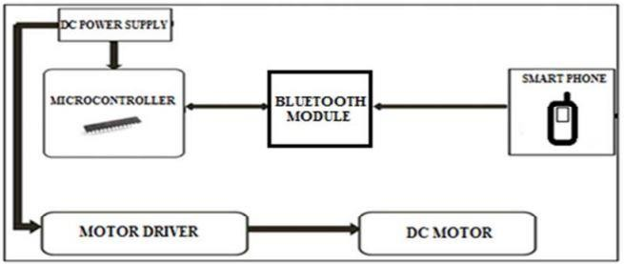

Here the Car part is driven using DC motors that are connected to the Motor Driver IC (L293D). This L293D Motor Shield is then connected with Arduino UNO and the these connections are made using Jumper Wires. The Connections are like the Male pins of the Motor Driver Shield gets inserted into the holes of Arduino UNO and the 4 DC Motors are Connected to the Driver IC as M1, M2, M3 and M4. Now the Bluetooth module (HC- 05) is connected to the Arduino UNO and the connections are as follows. The VCC of the Module is Connected to the 5V of the Arduino UNO, both the grounds are connected, The RX port is connected to the TX port of the Arduino UNO and vice-versa. All these connections are made using Jumper Wires. The power source is given to the Motor Driver IC as external source.

# Components Description

## 1. Bluetooth Module (HC-05) :

Bluetooth name of the device is “HC-05” and default PIN (password) for connection is either “0000” or “1234”. HC-05 module has 2 modes,

1. **Data mode :** Exchange of data between devices.
2. **Command mode :** It uses AT commands which are used to change setting of HC-05. Bluetooth serial modules allow all serial enabled devices to communicate with each other using Bluetooth.

## Pin Description of Bluetooth Module (HC-05) :

* 1. **VCC :** 5 volt supply should connect at this pin.
  2. **GND :** Ground of Micro Controller
  3. **TX :** Transmit Serial data (wirelessly received data by

Bluetooth module transmitted out serially on TXD pin)

* 1. **RXD :** Receive data serially (received data will be transmitted wirelessly by Bluetooth module).
  2. **State :** It tells whether module is connected or not.

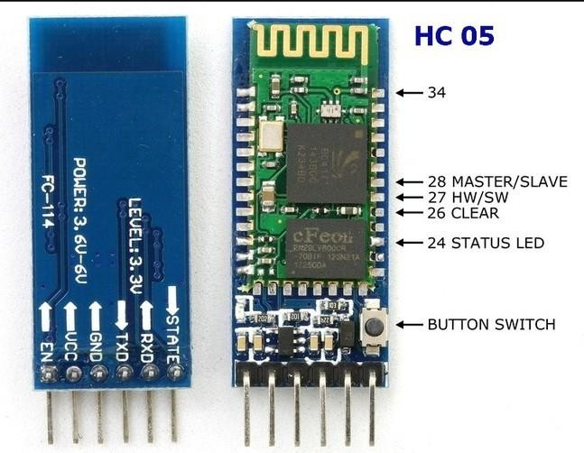

## Arduino UNO :

The **Arduino Uno** is an open source micro controller board based on the Microchip ATmega328P microcontroller and developed by [Arduino.cc](https://en.wikipedia.org/wiki/Arduino) The board is equipped with sets of digital and analog input/output (I/O) pins that may be interfaced to various expansion boards (shields) and other circuits. The board has 14 Digital pins, 6 Analog pins, and programmable with the [Arduino IDE](https://en.wikipedia.org/wiki/Arduino#Software) via a type B USB Cable It can be powered by the USB cable or by an external 9-V Battery though it accepts voltages between 7 and 20 volts.

## General pin functions :

* **LED**: There is a built-in LED driven by digital pin 13. When the pin is high value, the LED is on, when the pin is low, it's off.
* **VIN**: The input voltage to the Arduino/Genuino board. You can supply voltage through this pin.
* **5V**: This pin outputs a regulated 5V from the regulator on the board.
* **3.3 V** : A 3.3 volt supply generated by the on-board regulator. Maximum current draw is 50 mA.
* **GND**: Ground pins.
* **Reset**: Typically used to add a reset button to shields which block the

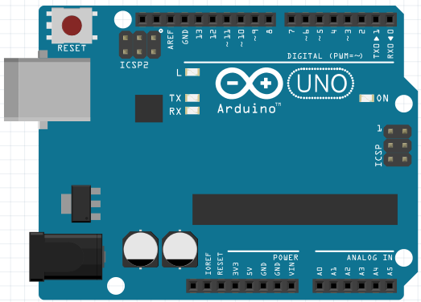one on the board.

## Motor Driver IC ( L293D ) :

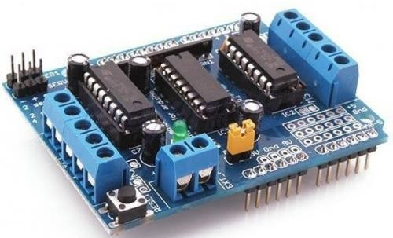A motor driver is an integrated circuit chip which is usually used to control motors in autonomous robots. Motor driver act as an interface between Arduino and the motors . These ICs are designed to control 2 DC motors simultaneously. L293D consist of two H-bridge. H-bridge is the simplest circuit for controlling a low current rated motor. We will be referring the motor driver IC as L293D only. L293D has 16 pins.

## 9V DC Motors :

A DC motor is any of a class of rotary electrical machines that converts direct current electrical energy into mechanical energy. It is Battery opted and has voltage of 3-9V. The speed is 60RPM.

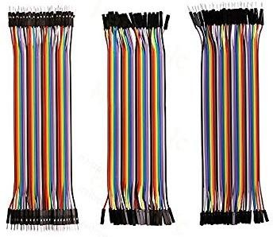

**M to M**

**F to F**

**F to M**

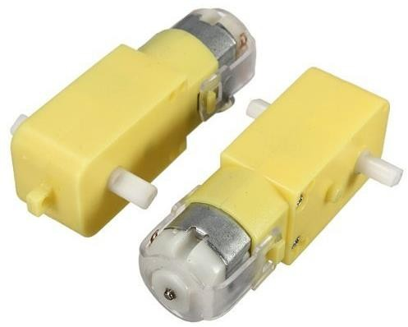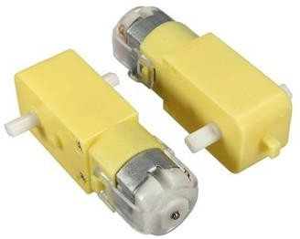

## Jumper Wires :

These are simply **wires** that have connector pins at each end, allowing them to be used to connect two points to each other without soldering

## Bluetooth Remote Control app :

Smart Phone The smart phone is the transmitter of this circuit. It sends the data to microcontroller through Bluetooth module. It also helps to send the instruction of forward, backward, left, right to the microcontroller. Actually, the smart phone is used as a remote of this system. Here we the Bluetooth RC Controller application as the operating remote of this system. The advantage of this project is that the application software designed for android phones is kept simple but attractive with all necessary built-in functions. The novelty lies in the simplicity of the design and functioning.

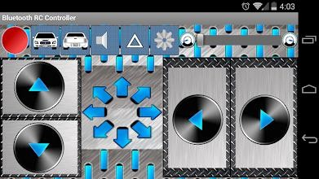

# Working of the Project

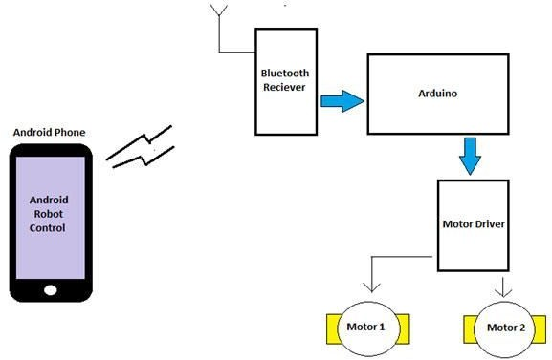The working principle is kept as simple as possible. The working principle of the circuit has been elaborated with the help of a block diagram, of the system interconnection. A DC power supply is required to run the system. The DC power supple feeds the Microcontroller and the Bluetooth module. The Bluetooth module receives the signal sent from an android smart-phone, where the application software coded in C language is installed. The microcontroller, thereby, sends instructions, which when executed, helps in functioning of the motor driver. When a key is pressed, the corresponding data is transmitted to the Bluetooth Module from the Phone over **Bluetooth Communication**. The movement and functioning of the motor can be controlled by using the android based application software. In our android application base Bluetooth controlled robotic car, the user interacts with the system with a smart phone. In this method user must be present within in range (< 15 meters) to control the system.

# Images of Original Circuit

**Coding :**

#include <AFMotor.h>

//initial motors pin AF_DCMotor motor1(1, HIGH); AF_DCMotor motor2(2, HIGH); AF_DCMotor motor3(3, HIGH); AF_DCMotor motor4(4, HIGH);

char command;

void setup()

{

Serial.begin(9600);.

}

void loop(){ if(Serial.available() > 0){ command = Serial.read();

Stop(); //initialize with motors stoped

//Change pin mode only.

//Serial.println(command);

switch(command)

{

case 'F': forward(); break;

case 'B':

back(); break; case 'L':

left(); break; case 'R':

right();

break;

}

}

}

void forward()

{

motor1.setSpeed(255); //Define maximum velocity motor1.run(FORWARD); //rotate the motor clockwise motor2.setSpeed(255); //Define maximum velocity motor2.run(FORWARD); //rotate the motor clockwise motor3.setSpeed(255);//Define maximum velocity motor3.run(FORWARD); //rotate the motor clockwise motor4.setSpeed(255);//Define maximum velocity motor4.run(FORWARD); //rotate the motor clockwise

}

void back()

{

motor1.setSpeed(255); //Define maximum velocity motor1.run(BACKWARD); //rotate the motor anti-clockwise motor2.setSpeed(255); //Define maximum velocity motor2.run(BACKWARD); //rotate the motor anti-clockwise motor3.setSpeed(255); //Define maximum velocity motor3.run(BACKWARD); //rotate the motor anti-clockwise motor4.setSpeed(255); //Define maximum velocity motor4.run(BACKWARD); //rotate the motor anti-clockwise

}

void left()

{

motor1.setSpeed(255); //Define maximum velocity motor1.run(BACKWARD); //rotate the motor anti-clockwise motor2.setSpeed(255); //Define maximum velocity motor2.run(BACKWARD); //rotate the motor anti-clockwise motor3.setSpeed(255); //Define maximum velocity motor3.run(FORWARD); //rotate the motor clockwise motor4.setSpeed(255); //Define maximum velocity motor4.run(FORWARD); //rotate the motor clockwise

}

void right()

{

motor1.setSpeed(255); //Define maximum velocity motor1.run(FORWARD); //rotate the motor clockwise motor2.setSpeed(255); //Define maximum velocity motor2.run(FORWARD); //rotate the motor clockwise motor3.setSpeed(255); //Define maximum velocity motor3.run(BACKWARD); //rotate the motor anti-clockwise motor4.setSpeed(255); //Define maximum velocity motor4.run(BACKWARD); //rotate the motor anti-clockwise

}

void Stop()

{

motor1.setSpeed(0); //Define minimum velocity motor1.run(RELEASE); //stop the motor when release the button motor2.setSpeed(0); //Define minimum velocity motor2.run(RELEASE); //rotate the motor clockwise motor3.setSpeed(0); //Define minimum velocity motor3.run(RELEASE); //stop the motor when release the button motor4.setSpeed(0); //Define minimum velocity motor4.run(RELEASE); //stop the motor when release the button

}

void left()

{

motor1.setSpeed(255); //Define maximum velocity motor1.run(BACKWARD); //rotate the motor anti-clockwise motor2.setSpeed(255); //Define maximum velocity motor2.run(BACKWARD); //rotate the motor anti-clockwise motor3.setSpeed(255); //Define maximum velocity motor3.run(FORWARD); //rotate the motor clockwise motor4.setSpeed(255); //Define maximum velocity motor4.run(FORWARD); //rotate the motor clockwise

}

void right()

{

motor1.setSpeed(255); //Define maximum velocity motor1.run(FORWARD); //rotate the motor clockwise motor2.setSpeed(255); //Define maximum velocity motor2.run(FORWARD); //rotate the motor clockwise motor3.setSpeed(255); //Define maximum velocity motor3.run(BACKWARD); //rotate the motor anti-clockwise motor4.setSpeed(255); //Define maximum velocity motor4.run(BACKWARD); //rotate the motor anti-clockwise

}

void Stop()

{

motor1.setSpeed(0); //Define minimum velocity motor1.run(RELEASE); //stop the motor when release the button motor2.setSpeed(0); //Define minimum velocity motor2.run(RELEASE); //rotate the motor clockwise motor3.setSpeed(0); //Define minimum velocity motor3.run(RELEASE); //stop the motor when release the button motor4.setSpeed(0); //Define minimum velocity motor4.run(RELEASE); //stop the motor when release the button

}

# Advantages of the Project :

* Easy to handle and operate.
* Low Power Consumption.
* User Friendly.
* Single Equipment and Multiple applications.
* Rate of Data transfer is very fast.
* Easily portable and can be placed anywhere.
* The basic advantage of this system is its wide interface that can be

controlled with help of Android Mobile from a few feet away, and also that the whole system syncs itself with the driver’s electronic devices, thus giving him/her greater accessibility.

* No prior Training is needed.

# Applications :

❏ They can be used by Physically Challenged people to helm their robot around their space.

* These robots are used in Military and Medical purposes.
* The robot can be used for reconnaissance or surveillance.
* It is used in construction domain and in industry for controlling and operating the things.

# Future Scope :

* **Medical Applications –** Advanced robotics systems with Bluetooth recognition can be placed in hospitals or homes to recognize and treat life threatening conditions like heart attacks or strokes.
* **Alternative computer interfaces –** Bluetooth Control, along with voice recognition, facial recognition, lip movement recognition and eye tracking combined can be used to create something called a perceptual user interface (PUI), a completely different way to interact with computer systems which will improve usability and creativity by leaps and bounds.
* **Advanced Version :** We can interface sensors to this robot so that it can monitor some parameters. We can add wireless camera to this robot.
* **Automation systems –** In homes, offices, transport vehicles and more, Bluetooth recognition can be incorporated to greatly increase usability and reduce the resources necessary to create primary or secondary input systems like remote controls, car entertainment systems with buttons or similar.
* **An easier life for the disabled –** One of the biggest challenges faced today is providing separate and equally non cumbersome services to the differently abled and handicapped. While there are special provisions around the world, there’s still huge room for improvement to bring all lives on equal footing. Bluetooth Control technology can eliminate a lot of manual labor and make life much easier for those who aren’t as fortunate as most of us are.

# Conclusion :

* This is indeed a cost-effective and efficient project. The novelty lies in the fact that it is a cost-effective project with a simple and easy to use interface compared to existing ones.
* Also the Bluetooth RC Controller application is more user friendly. The robot is small in size so it can be used in spying purpose. With few additions and modifications, this robot can be used in army for detecting and disposing hidden land mines.
* The robot can be used for surveillance. In future we can interface sensors to this robot so that it can monitor some parameters and we can improve the efficiency using Internet of Things (IoT) technology.
* We can also add wireless camera, in order to incorporate other security features. We are now living in the 21st century. Now, smart phone has become the most essential thing in our daily life.
* Android application based smart phones are becoming each time more powerful and equipped with several accessories that are useful for Robots.

# References :

1. Information Reference : [(https://www.slideshare.net/SimarjotSinghKalsi/bluetooth-controlled- robot-project-report )](https://www.slideshare.net/SimarjotSinghKalsi/bluetooth-controlled-robot-project-report)
2. Idea of the Project :

(<https://www.youtube.com/watch?v=Ap-SZHJF8wU>)

1. Saurabh A. Khajone, Dr. S. W. Mohod, V.M.Harne “Implementation of a Bluetooth Controlled Robotic Car” in IJIRCCE Vol. 3, Issue 1, January 2015.
2. International Research Journal of Engineering and Technology (IRJET) e-ISSN: 2395-0056 Volume: 05 Issue: 02 | Feb-2018
3. International Journal of Advanced Research in

Computer Science and Software Engineering Volume 6, Issue 6, June 2016 ISSN: 2277 128X

1. Purchase of Items :

( <https://www.amazon.com/electrical/b?node=495266>)